Steeple Aston Parish Council
Additional meeting

27th November 2023 at 8pm in the Village Hall

Agenda & Summons to Councillors and Invitation to Members of the Public

No | Detail | Lead
1 | To receive apologies for absence | Chair
2 | Declarations of Interest - to receive any declarations of interest from Councillors relating to items on the agenda, in accordance with the Council’s code of conduct. | All
3 | Public Participation - to receive submissions from members of the public relating to items on the agenda, in accordance with the Council’s code of conduct & standing orders.  Variation of Order of Business may apply | Chair
4 | MCNP site Allocation for Steeple Aston – to discuss recommendations and reach a decision | M. Lipson

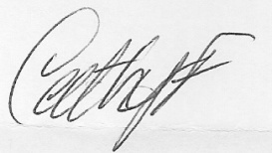 Cathy Fleet – Parish Clerk – 07989 398 838 Public & Press invited

